Spatial dynamics of animal-mediated nutrients in temperate waters

Em G Lim¹, Claire M Attridge¹, Jasmin M Schuster^{2,3}, Kieran D Cox¹, Kiara R Kattler¹, Emily J Leedham¹, Bridget Maher², Andrew L Bickell², Francis Juanes², Isabelle M Côté¹

¹Department of Biological Sciences, Simon Fraser University, Burnaby, British Columbia, Canada
²Department of Biology, University of Victoria, Victoria, British Columbia, Canada
³Hakai Institute, Campbell River, British Columbia, Canada

Abstract
Consumer-mediated nutrient dynamics (CND), through which animals’ metabolic waste products fertilize primary producers, drives variability in nutrient availability and thus primary productivity and community functioning in tropical waters. Yet, examinations of CND as a driver of variation in nutrient availability in temperate marine ecosystems are limited. To assess the scale and drivers of spatial variation in CND within temperate marine ecosystems, we quantified the occurrence of 48 fish and 92 macroinvertebrate taxa and measured their ammonium excretions at 27 northeast Pacific rocky reefs for three years and 17 kelp forests of varying density for a single year. Ammonium concentrations ranged from 0.01 to 2.5 uM across rocky reefs, and the relationship between animal biomass and ammonium was weakly positive at slack and ebb tides, but weakly negative at flood tide. Ammonium was significantly higher within than adjacent to kelp forests, a difference that increased with tide exchange, kelp biomass, and animal biomass. Using caging experiments, we found that fine-scale ammonium variability and nutrient enrichment on a scale of meters was only possible under low-flow conditions. Our results suggest CND-driven variability acts on scales ranging from a few meters to over 20 km, contributing to finer-scale variation in nutrient availability than allochthonous nutrient sources such as upwelling. Therefore, CND may play a previously unrecognized role in structuring temperate marine ecosystems from the bottom up.

Introduction
Variation in resource availability across spatial and temporal scales can drive substantial heterogeneity in the growth, biomass and composition of primary producers (Dayton et al., 1999; Leibold, 1991; McInturf et al., 2019; Tilman, 1984). In many marine ecosystems, community structure is under bottom-up control, i.e. it depends on factors that generate variability in the resources available to lower trophic levels (Gruner et al., 2008). Although marine ecologists have historically focused on external, abiotic sources of nutrients, such as upwelling, as drivers of variability in nutrient availability, there is now substantial evidence that consumers also contribute to bottom-up effects (Allgeier et al., 2017). Animals’ metabolic waste products (i.e., excretion and egestion) fertilize primary producers via a process termed consumer-mediated nutrient dynamics (Vanni, 2002). However, the ecological importance of consumer-regenerated nutrients across scales remains unclear. Therefore, identifying the scales at which biologically relevant variation in nutrient availability contributes to community structure remains an active area of research (Allgeier et al., 2017).
Heterogeneity in consumer habitat use contributes substantially to spatial and temporal variation in nutrients supplied by animal waste (Benkwitt et al., 2019; Roman and McCarthy, 2010; Uthicke, 2001). For example, tropical coral reefs provide habitat, shelter, and food sources that attract dense aggregations of vertebrate and invertebrate consumers, which regenerate nutrients (Archer et al., 2015; Meyer et al., 1983; Shantz et al., 2015). On a broad scale, productivity increases with proximity to reefs with high densities of fishes (Layman et al., 2016), while on a finer scale, sheltering schools of fish increase nitrogen concentrations around individual heads of corals relative to neighboring uninhabited corals (Holbrook et al., 2008). Diurnal migrations are a source of temporal variation as some fishes travel from their nighttime feeding grounds to daytime hiding spots, transporting substantial quantities of nitrogen in their tissues with them (Francis and Côté, 2018; Meyer and Schultz, 1985). Even larger-scale temporal and spatial variation can arise from the migration of megafauna; whales transport and deposit nutrients across thousands of kilometers as they travel from their feeding to breeding grounds (Doughty et al., 2016). However, the current understanding of animal-driven spatio-temporal variability of nitrogen is drawn substantially from tropical ecosystems (Allgeier et al., 2013; Holbrook et al., 2008; Meyer et al., 1983), often overlooking productive temperate marine ecosystems.
In temperate waters, external sources of nutrients, such as upwelling and freshwater runoff, are generally thought to be dominant drivers of nitrogen variability (Dayton et al., 1999; Mann, 1973). Due to the open nature of nearshore environments, high water flow due to currents, tides, and wave action are theorized to limit small-scale nutrient variation (Probyn and Chapman, 1983). Therefore, research on intertidal and shallow subtidal ecosystems has traditionally focused on top-down, trophic interactions as drivers of community composition at small scales (1 to 100 m²), and considered resource limitation mainly at large, regional or continental scales (Menge, 1992; Paine, 1986). However, evidence suggests meso-scale (10 to 100 km) variation in allochthonous nitrogen via upwelling may contribute to bottom-up control of benthic marine communities (Nielsen and Navarrete, 2004) and even weaken top-down control (Sellers et al., 2020). For example, the amount of nitrogen regenerated by intertidal mussel beds varies with mussel cover along an entire coastline (Pfister et al., 2014). In a nearby wave-exposed shoreline, mussels also contribute to nutrient regeneration on small, local scales by increasing the concentration of nitrogen in the water column directly over the beds (Aquilino et al., 2009). Vertical gradients in ammonium concentration in the water column can also arise from microbial remineralization in marine sediments (Lowman et al., 2023). Therefore, regenerated nitrogen may contribute substantially to large-, meso-, and small-scale variation in nutrient availability, even in high-flow, upwelling nearshore coastal ecosystems.
Shallow subtidal rocky reefs and kelp forests are two charismatic temperate nearshore communities that attract dense aggregations of fishes and invertebrates, many of which are economically, ecologically, and culturally important (Steneck et al., 2002). These animals excrete metabolic waste in the form of ammonium (NH₄⁺), which is preferentially taken up by primary producers over other forms of nitrogen like nitrate and nitrite (Lobban and Harrison, 1994; Phillips and Hurd, 2004). The elevated levels of biomass and biodiversity that occur within these habitats may also contribute to nutrient hotspots on small to meso scales. Fast-growing canopy kelps, which form expansive underwater forests, may benefit from these excretions directly as a source of nitrogen, especially during low upwelling periods (Brzezinksi et al., 2013). These kelps, which comprise giant kelp (Macrocystis pyrifera) and bull kelp (Nereocystis leutkeana) in the northeast Pacific region, also affect seawater hydrodynamics and physical composition, both slowing water flow within forests and creating gradients of carbon content, pH, alkalinity, and oxygen (Gaylord et al., 2007; Pfister et al., 2019). These modifications to the physical environment could affect the productivity and community composition of other primary producers, also contributing to small-scale spatial heterogeneity.
We aimed to quantify the contribution of regenerated nutrients to spatial variability of nutrients in a temperate, wave-swept upwelling region: Barkley Sound in British Columbia (BC), Canada. This region is located on the traditional territories of the Huu-ay-aht First Nations and comprises an archipelago of islands dotted with rocky reefs and kelp forests. Specifically, we measured variation in ammonium (NH₄⁺) concentrations among rocky reef sites (meso scale of ~10s of km), in and out of kelp forest sites (small scale of ~10s of m), and near experimentally caged consumers (smaller scale of < 10 m). We quantified the abundance and diversity of fishes and invertebrates at each rocky reef and kelp forest site, measured kelp forest metrics, and other abiotic variables to explore drivers of potential variation in NH₄⁺ concentrations. Due to this region’s external nutrient sources and high flow, we did not expect consumer-mediated nutrient dynamics to contribute substantially to small-scale nutrient variability, but we hypothesized that meso-scale, among-site variation may be possible under normal mixing conditions. By characterizing the scale at which animal-driven nutrients vary in this temperate region, we hope to elucidate the potential for consumers to structure communities not only from the topdown, but also the bottom up.

Methods
Site description
Barkley Sound is located in an upwelling region on the west coast of Vancouver Island, Canada. Upwelling supplies nitrates in the spring and early summer, while storms flush riverine inputs into the nearshore in the winter and spring (Pawlowicz, 2017). Due to the proximity of the Bamfield Marine Sciences Centre (BMSC), this region has been a long-term focal area for studies seeking to unravel ecosystem dynamics, document large-scale patterns of kelp response to heatwaves and establish ecological baselines (Attridge et al., 2024; Howard et al., 2019; Starko et al., 2024, 2022; Tanasichuk, 1998). Subtidal fish communities comprise at least 18 families including gobies, surfperches, rockfishes, greenlings, and sculpins (cite RLS?). Invertebrate assemblages, which are made up of over 49 families, are dominated by urchins, turban snails, sea stars, abalone, and sea cucumbers (cite RLS).

Surveys of among-site (meso-scale) variation
To explore meso-scale variation in animal-regenerated nutrients among rocky reefs, we measured ammonium (NH₄⁺) concentrations and surveyed fish and invertebrate communities at 27 subtidal sites ranging from 0.06 – 24 km apart in Barkley Sound (Fig. 1). We collected subtidal NH₄⁺ samples paired with fish and invertebrate surveys using a globally standardized method (i.e., Reef Life Survey, RLS) at each site. We conducted our surveys between the end of April and middle of May for three years (2021-2023), with all annual surveys occurring within 2 weeks of each other (Supplemental Table 1). A full explanation of the Reef Life Survey method is available online (http://www.reeflifesurvey.com/methods) and provided by Edgar and Stuart-Smith (2009) and Edgar et al. (2020). Briefly, at each rocky reef site, a pair of trained SCUBA divers assessed fish and invertebrate abundance and diversity along each side of a 50 m transect line (Fig. 2). First, fishes in the water column were counted and sized (total length, in various size class categories) within 5 m on either side of the transect line (500 m²), and then benthic cryptic fishes (also sized) and large mobile invertebrates (> 2.5 cm) were counted within 1 m on either side of the transect line (100 m²).
Immediately following each RLS survey, we collected three 60 mL subtidal seawater samples at 0, 25, and 50 m along the transect at consistent depths and stored the syringes in sealed plastic bags upon collection to prevent contamination. Seawater samples were filtered into amber bottles in the field and frozen for a maximum of two weeks before NH₄⁺ analysis. We confirmed that freezing samples for this duration did not affect NH₄⁺ concentration (Lim, unpublished data). In 2021 and 2022, we followed the fluorometric method using 40 mL seawater samples (Holmes et al., 1999), and in 2023, we followed the fluorometric standard-additions protocol II (Taylor et al., 2007). The three NH₄⁺ samples collected during each survey were averaged to determine the mean NH₄⁺ concentration for each site.

Surveys of within-site (small-scale) variation
To investigate within-site variation in animal-regenerated nutrients, we measured NH₄⁺ concentrations in and around kelp forests and surveyed the neighbouring biological communities as potential moderators of this variation. Our 16 sites comprised forests of varying densities dominated by giant kelp (Macrocystis pyrifera) or bull kelp (Nereocystis luetkeana), as well as two no-kelp control sites. We conducted our surveys from July to September 2022 (Supplemental Table 2). First, to quantify the abundance and biodiversity of animal communities associated with each kelp forest, divers surveyed fish and invertebrate communities along 50 m transect lines placed immediately adjacent to the edge of the kelp forest following the RLS protocol as above. Next, we ran four 1 m-wide, 5 m-long transects, 5 m apart, into the kelp forest to assess kelp density, canopy height, and biomass (Fig. 2). Divers then counted the number of canopy kelp individuals (bull or giant kelp) within 0.5 m on either side of the kelp transect to measure kelp density. To estimate canopy height, we measured the length of five randomly chosen kelp individuals per kelp transect; for bull kelp we measured the total length from holdfast to pneumatocyst in situ, but for giant kelp we collected five random individuals to measure from holdfast to apical meristem on dry land. To quantify bull kelp biomass, we measured the sub-bulb circumference (15 cm below the bottom of the bulb) of the same five bull kelps per transect in situ and calculated individual biomass using a quadratic diameter to biomass formula (Attridge, unpublished data). For giant kelp biomass, we weighed using X brand scale the same five individuals per transect that were collected for total length measurements. We multiplied the mean biomass estimate for each kelp species by the species density to calculate a biomass/m² estimate for each kelp transect, which we then averaged over the four transects per forest to estimate overall mean forest biomass/m². We estimated total forest area by swimming around the perimeter of the forest on the surface with a Garmin GPS, which we used to calculate total forest biomass (kg).
Finally, to compare NH₄⁺ concentrations inside vs outside each kelp forest, we collected paired 60 mL syringes of seawater immediately outside the kelp forest within 0 – 2 m from the substrate, and 5 m into the kelp forest at the same depth. We collected three paired NH₄⁺ samples from each site, which were spaced 5 m apart by matching them with the first three kelp transects. Outside each kelp forest, we also filled a Whirl-PakTM sample bag with seawater for creating standards. Samples and standards were filtered into amber bottles in the field and stored on ice for transportation back to the laboratory, at which point we measured NH₄⁺ concentration in each sample bottle following the fluorometric standard-additions protocol II for 40 mL samples (Taylor et al., 2007). For each paired inside and outside kelp forest NH₄⁺ sample, we calculated ∆ NH₄⁺ = inside NH₄⁺ - outside NH₄⁺.

Surveys of within-meters (smaller-scale) variation
To quantify the ability of animals to affect the NH₄⁺ concentration in their immediate vicinity we conducted two caging experiments in situ near Bamfield. The first caging experiment took place at Scott’s Bay (48°50'05.2"N, 125°08'49.3"W), a wide, exposed bay that opens on Trevor Channel (Fig. 1), on May 27 – 28, 2021. We constructed 18 wire cages (26 x 26 x 26 cm), which we covered in 2 mm plastic mesh. These cages were spaced 3 m apart along two weighted lines and deployed at 3 to 5.8 m depth (9 cages per line). We collected California sea cucumbers (Apostichopus californicus) from the site via SCUBA, measured contracted sea cucumber length and girth, and immediately placed them into the cages in randomly assigned densities of 0, 1, or 2 sea cucumbers (n = 6 replicates per density). After 24 h, we returned to collect water samples from each cage in situ. While underwater, we minimized water movement by reducing our fin and hand movements while opening the mesh lids, which were secured with wire, just wide enough to collect a 60 mL syringe of seawater. Once at the surface, we filtered 40 mL of each sample into amber bottles and transported them on ice to the lab, where we measured NH₄⁺ using the fluorometric method (Holmes et al., 1999).
The second caging experiment took place in Bamfield Inlet (48°49'53"N 125°08'11"W), a narrow, sheltered inlet (Fig. 1), from June 10 – 19, 2023, and we replicated it from June 19 – 28, 2023 following the same methodology. For these experiments, we used red rock crabs (Cancer productus). We collected crabs from the site using crab traps and kept them at BMSC in flow-through sea tables for 2 – 10 days. Crabs were fed salmon every 2 – 4 days, and all crabs were fed the night before each experiment started. We constructed 12 cages from clear plastic (40 x 28 x 17 cm), with two 15 x 9 cm windows covered in a dual layer of 10 mm plastic mesh and 1 mm mesh to allow for water flow. The cages were randomly distributed every 2 m along a lead line anchored with cement buckets 0.8 m below chart datum. Each cage contained either one large crab (carapace 15.0 – 15.9 cm), one medium size crab (11.6 – 14.4 cm), or a control (i.e., a small rock, scraped clean, to weight the cages similarly to the crabs) (n = 4 replicates per experiment). During both experiments, we replaced the crabs after 4 days with freshly fed, similar-sized crabs, at which point we re-randomized the order of the cages along the line. We measured seawater NH₄⁺ concentration via snorkel at low tide at the beginning, middle, and end of each nine-day experiment by drawing water samples using a 60 mL syringe and a fixed narrow rubber tube that began in the centre of the cage and extended several inches outside the mesh window. We filtered 40 mL of each sample into amber bottles, which were stored on ice before NH₄⁺ analysis via fluorometric standard-additions protocol II (Taylor et al., 2007).

Statistical analyses
All statistical analysis were conducted in R (v4.1.2, R Core Team, 2019) using RStudio (v1.3.1093, RStudio Team, 2016). We used tidyverse packages for data manipulation and visualization (Wickham et al., 2019), ‘glmmTMB’ for all modelling (Brooks et al., 2017), and DHARMa to check model fit (Hartig, 2022). All data and code are available at https://github.com/em-lim13/Ch2_Spatial_pee.
For each Reef Life Survey conducted, we calculated fish biomass from fish length following the formula (W = a*L^{b}) where W is fish weight, L is the fish length, a and b are species-specific constants from FishBase (Froese et al., 2014). For invertebrates, sunflower sea stars and economically important species (abalone and scallops) were measured, so we used published length-weight relationships to calculate wet weight from size. For all other invertebrates, we used published wet weight estimates from this region to estimate rough average biomass estimates for each taxon. We used shell-free wet weight for species with large shells such as hermit crabs and snails. When biomass information was unavailable for a species, we used estimates from the closest relative or most similarly sized species available (Supplemental Table 3). Animal abundance per m² was calculated as the total number of fishes and invertebrates counted on each survey (divided by 500 m² for pelagic fishes and by 100 m² for cryptic fishes and macroinvertebrates), and we used the ‘vegan’ package to calculate Shannon and Simpson diversity indices (Oksanen et al., 2022). We calculated the tide exchange by computing the rate of change of the tide height every minute, starting from the time each survey started and ending one hour later, and taking the average of those values. We downloaded tide height data from the website: http://tbone.biol.sc.edu/tide/tideshow.cgi?site=Bamfield%2C+British+Columbia.

Among-site (meso-scale) variation
To determine whether there was significant variation in NH₄⁺ among sites, we constructed generalized linear mixed-effect models (GLMMs) with NH₄⁺ concentration as the response variable, and animal abundance, tide exchange, an interaction between abundance and tide, Shannon diversity, and survey depth as predictors, and random effects of site (1|site) and year (1|year). All predictors were scaled and centered around the mean using the scale function. We used a gamma distribution (link = ‘log’). We constructed additional models with animal biomass as a predictor instead of abundance, and Simpson’s diversity instead of Shannon diversity, but we determined that abundance and Shannon diversity were the best metrics by comparing alternative models using AIC (Supplemental Table 4). We checked for collinearity of variables using car::vif, and all values were below 1.9. We visually inspected model residuals by plotting the output from DHARMa::simulateResiduals, and the model met all assumptions. We ran additional models considering the effect of only the most abundant families of fishes and invertebrates, which are fully described in Electronic Supplement 2.

Within-site (small-scale) variation
To determine whether NH₄⁺ concentration differed inside and outside of kelp forests, we used a linear mixed-effects model (LMM) with ∆ NH₄⁺ as the response variable (n = 3 estimates per site), and kelp species, mean forest kelp biomass/m², tide exchange, animal biomass, survey depth, Shannon diversity, and interactions between kelp biomass and tide exchange, kelp biomass and animal biomass, and animal biomass and tide exchange as fixed effects. All continuous predictors were scaled and centered around the mean as above. We included site as a random effect (1|site) to account for the fact that each site contributed 3 estimates to the analysis and used a Gaussian distribution. As above, we chose our final set of predictors upon comparing AIC values of models with animal abundance instead of biomass, and Simpson’s diversity instead of Shannon diversity (Supplemental Table 5). We inspected residuals using DHARMa::simulateResiduals, checked for collinearity between variables, and the model met all assumptions. We also ran our final model with centred continuous variables instead of scaled variables to facilitate interpretation of coefficients in the results. Finally, we ran additional models considering the effect of only the most abundant families of fishes and invertebrates, which are fully described in Electronic Supplement 2.

Within-meters (smaller-scale) variation
To quantify the impact of caged animals on NH₄⁺ concentration, we constructed separate linear models for each caging experiment. For the sea cucumber experiment, we regressed cage NH₄⁺ concentration against the treatment (i.e., sea cucumber density: 0, 1, or 2 sea cucumbers) and cage depth (centered) using a Gaussian distribution. The model met all assumptions upon inspection of the residuals. For the red rock crab experiment, we constructed a generalized linear mixed-effects model with cage NH₄⁺ concentration as the response variable and treatment (no crab, medium crab, or large crab) as the predictor variable. We included a random effect of sampling day because we measured NH₄⁺ three times per experiment, and a random effect of experimental week, because we replicated the whole experiment twice. We used a gamma distribution (link = ‘log’) to ensure model residuals met all assumptions.

Results
We found evidence of meso-scale variation in ammonium (NH₄⁺) concentrations, which ranged from 0.01 μM – 2.54 μM among rocky reefs in Barkley Sound (Fig. 1). Overall, we found no evidence that NH₄⁺ concentration was correlated with animal abundance (GLMM, p = 0.57), tide exchange (p = 0.99), Shannon diversity (p = 0.41), or survey depth (p = 0.61, Fig. 3a). However, we did find a significantly negative interaction between animal abundance and tide exchange (p = 0.01, Fig. 3b), revealing a weakly positive effect of total animal abundance per m² on NH₄⁺ concentration, but only at ebb tide.
We also found evidence of small-scale, within-site variation; NH₄⁺ concentrations were significantly higher inside than outside giant kelp forests (LMM, mean difference ± SE; 0.16 ± 0.03 μM, p < 0.001) and bull kelp forests (0.41 ± 0.06 μM, p < 0.001). The ‘excess’ NH₄⁺ concentration inside kelp forests increased by 0.54 ± 0.09 μM per unit of kelp biomass (kg/m²) (p < 0.001), and with tide exchange (0.36 ± 0.13 μM per unit of tidal speed, m/s, p = 0.007). We found limited evidence for an effect of animal biomass (p = 0.07, Fig. 4a, b), survey depth (p = 0.07) (Fig. 4a), and Shannon diversity on ∆ NH₄⁺ (p = 0.09). We found evidence of a positive interaction between kelp forest biomass and tide exchange, whereby the positive effect of kelp biomass on ∆ NH₄⁺ increased with tide exchange (2.65 ± 0.71, p < 0.001, Fig. 4b). We also found a negative interaction between kelp biomass and animal biomass (- 0.83 ± 0.30, p = 0.006), and a negative interaction between tide exchange and animal biomass (- 4.23 ± 1.45, p = 0.004, Fig. 4a). ∆ NH₄⁺ was negative between samples taken 5 m apart at the no-kelp control sites (-0.24 ± 0.08 μM, p = 0.003, Fig. 4a).
We found mixed evidence for animal-related variability in ammonium concentration at the smallest scale studied. For sea cucumbers, we found no effect of sea cucumber density on cage NH₄⁺ concentration, which was 0.92 ± 0.04 μM across all cages (LM, p > 0.75 for both treatments, Fig. 5a). However, we did find a positive effect of cage depth, whereby NH₄⁺ increased by 0.38 ± 0.05 μM per m increase in depth (p < 0.001). For red rock crabs, both medium and large crabs significantly increased the cage NH₄⁺ concentration relative to control cages, by 804 % and 1266 % respectively (GLMM, p < 0.001 for all, Fig. 5b).

Discussion
Paragraph 1: restate results from each spatial scale and address hypotheses. We found evidence of meso-scale, small-scale, and very small-scale variation in NH₄⁺. Flow and animals were important at all three scales.

Paragraph 2: Among-site. What is the magnitude of variability? (it’s HUGE if you express as fold difference between highest and lowest) How does that measure up to other drivers of variability (nitrates from upwelling!) Drivers of among-site variation? Flow vs animals? (explain the logic of an ebb-only effect (most likely reviewers won’t be marine people) Limitation: only getting snapshots of communities, we don’t consider intertidal communities, there’s also other sources of ammonium (microbial regeneration)

Paragraph 3. Within-site. More kelp and more flow = increased delta, and positive interaction so that relationship really cranks up! Magnitude of variability vs differences found in other in vs out kelp forests. Cite those kelp slows flow of water papers. Sounds like nitrates don’t concentrate in kelp but animal regenerated nutrients = preferred nutrient = concentrated around kelp! Cool! Limitation: only sampled on flood and slack, didn’t catch ebb.

Paragraph 4. Address the other in vs out predictors here! Why was delta nh4+ larger in Nereo vs Macro? Why the no kelp sites had negative delta ammonium. Negative interactions: almost an asymptote relationship? If you have a high level of one variable, increasing the other doesn’t infinitely increase the delta. Talk about animal biomass here. Address depth and biodiversity, both had near significant effects. Limitations: RLS surveys were on edge of kelp, not inside the forest, only one year of data.

Paragraph 5. Small scale! Magnitude of diff, has anyone else done super small scale stuff? Compare to that. Maybe the crabs had a diff bc that area had lower flow? But also address diff in flow between cages! Limitations: didn’t standardize cage design but these experiments weren’t to test the conditions under which fine-scale variation was possible, only to see if it WAS possible.

Paragraph 6: Do we think the amount of variability we found at each scale will amount to any effect on pp? Cite some CNC = growth papers that have similar levels of enrichment. Cite the papers that show nitrates in the summer are low?

Paragraph 7. Conclusions. Animals are contributing to variability! Mention magnitude of variability vs other sources (upwelling, run-off) BUT… do we know if this impacts pp? Set up Ch 3 kelp outplant experiment!
Figures
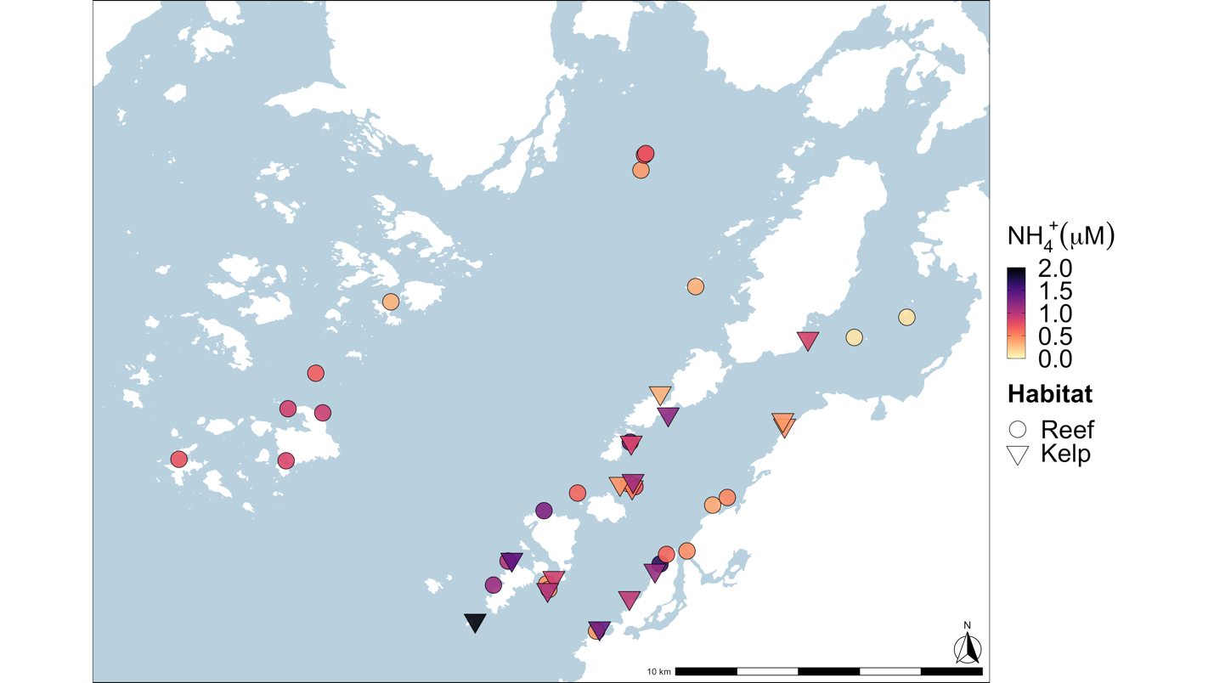Figure 1. Rocky reefs (circles) surveyed for among-site, meso-scale ammonium variation, and kelp forests surveyed (triangles) for within-site, small-scale ammonium variation in Barkley Sound, BC. Site colour indicates mean ammonium concentration found at each site across all three years, with darker points having higher concentrations of ammonium.

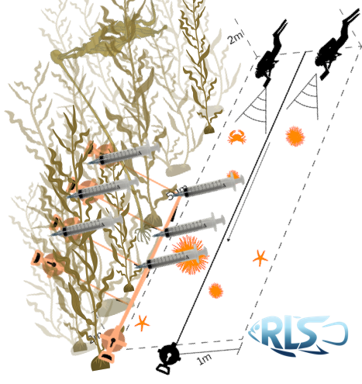
Figure 2. Placeholder schematic for the kelp pee samples. I will remake this!!!!!

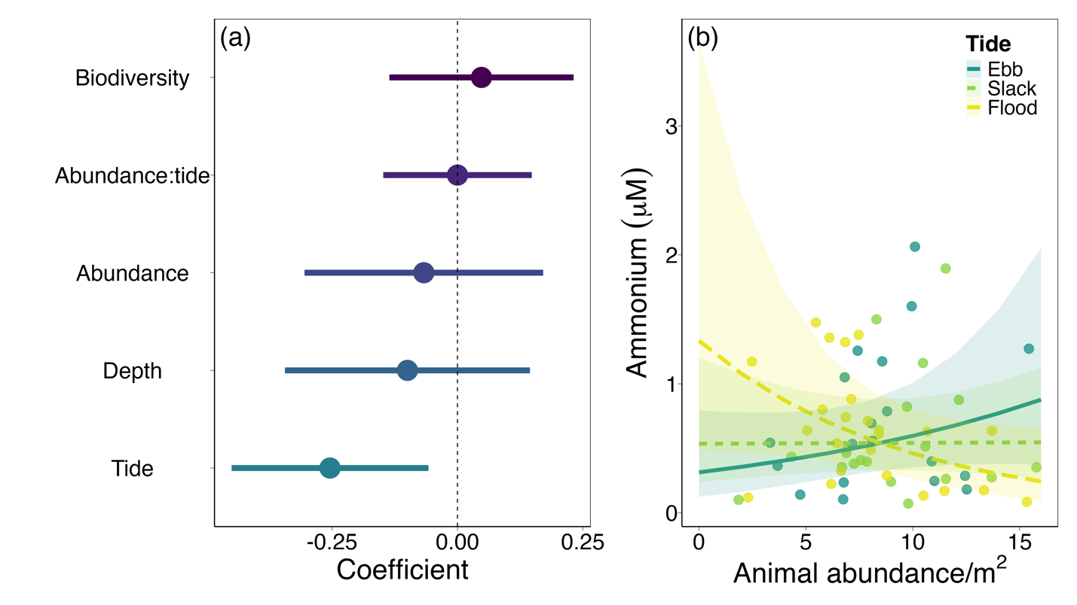
Figure 3. Ecological moderators of seawater ammonium concentration observed across 27 rocky reef sites in Barkley Sound, British Columbia, Canada. (a) Model coefficients surrounded by 95% confidence intervals, and (b) model-generated predictions for the investigation of among-site variation in ammonium concentration. The coefficients were generated from a generalized linear mixed-effects model, which used a gamma distribution (link = ‘log’) so coefficients are presented in log space. Continuous predictors were centred and scaled for comparison of effect sizes between predictors with varying units.

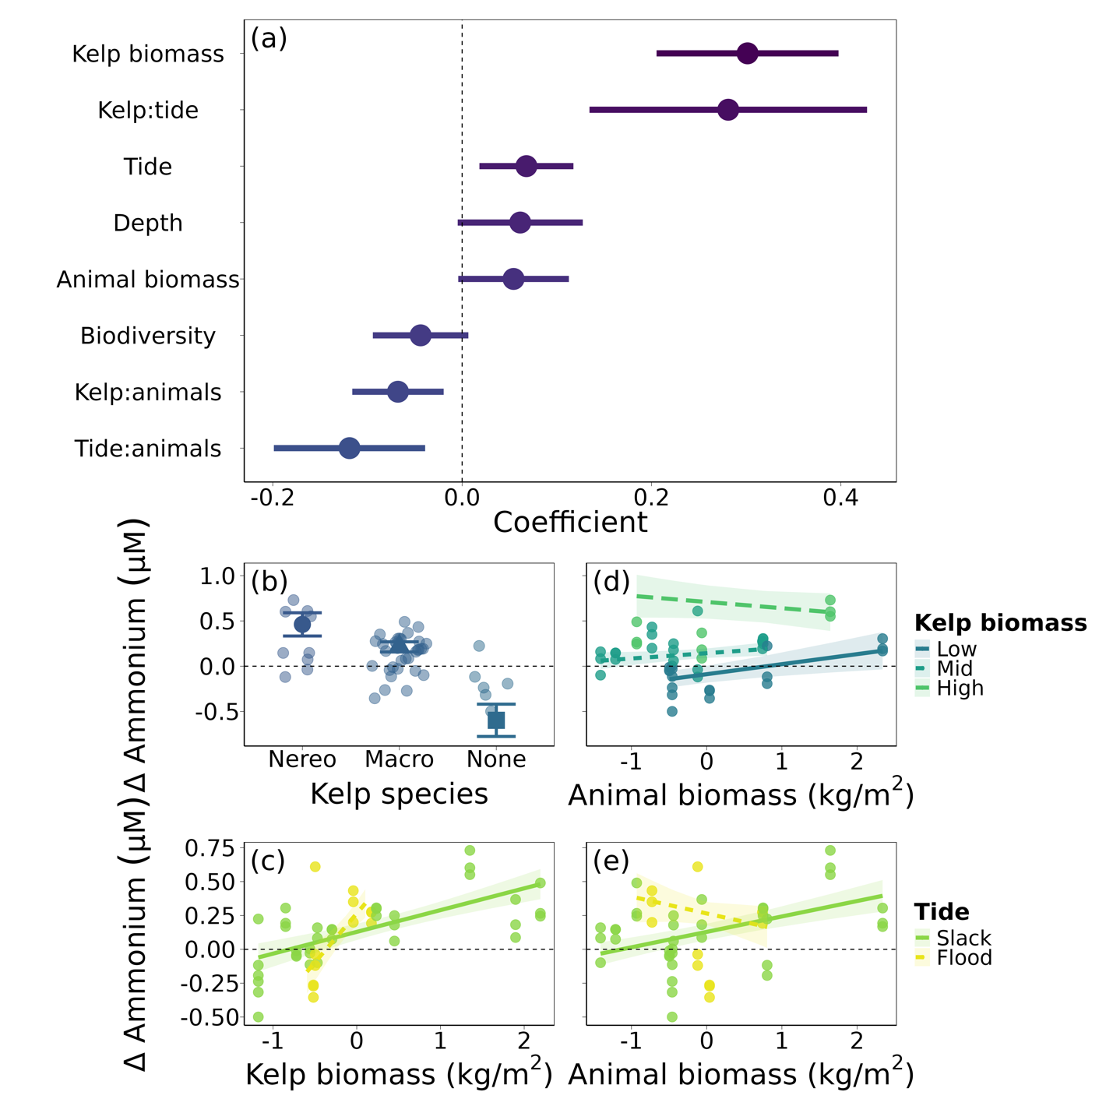
Figure 4. Drivers of variation in ammonium concentration inside vs outside kelp forests across 16 sites in Barkley Sound, British Columbia, Canada. (a) Model coefficients surrounded by 95% confidence intervals and (b) model-generated predictions for the investigation of within-site variation in ammonium concentration. Continuous variables were scaled and centered to facilitate comparisons between variables measured in different units.

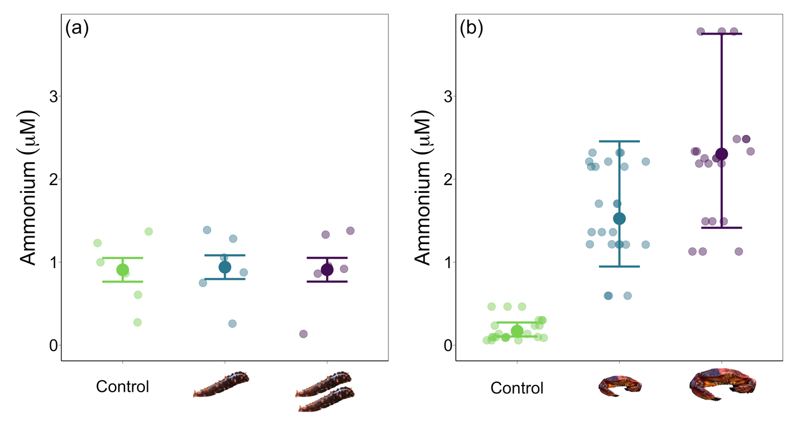
Figure 5. Smallest-scale effect of animals on ammonium concentration. Mean ammonium concentration in experimental cages containing (a) zero, one, or two California sea cucumbers, and (b) control, medium size, or large size red rock crab. Error bars indicate 95% confidence intervals.

Electronic Supplement 1. Supplementary tables and figures.
Supplemental Table 1. List of rocky reef sites sampled using Reef Life Survey methods, and the years each site was surveyed.
Site code | Site name | Coordinates | Years sampled
BMSC1 | Dodger Channel | 48.82894897, -125.1975708 | 2021, 2022, 2023
BMSC2 | Kirby | 48.85039902, -125.1987686 | 2021, 2023
BMSC3 | Ohiat | 48.85558319, -125.1837997 | 2021, 2022, 2023
BMSC4 | Kii xin | 48.81511688, -125.1753311 | 2021, 2023
BMSC5 | Taylor Rock | 48.82733154, -125.1966019 | 2021, 2022, 2023
BMSC6 | Baeria Rocks South Island | 48.95023346, -125.1555481 | 2021, 2022, 2023
BMSC7 | Baeria Rocks N Island Southside | 48.95464325, -125.1539917 | 2021
BMSC8 | Baeria Rocks N Island Northside | 48.95508194, -125.1533737 | 2021, 2022, 2023
BMSC9 | Eagle Bay | 48.83478928, -125.1470261 | 2021, 2022, 2023
BMSC10 | Ross Islets Slug Island | 48.87051773, -125.160347 | 2021, 2022, 2023
BMSC11 | Wizard Island South | 48.85746765, -125.1582336 | 2021, 2022, 2023
BMSC12 | Wizard Island North | 48.858284, -125.1609192 | 2021, 2022, 2023
BMSC13 | Effingham West | 48.8650322, -125.3137207 | 2021, 2022
BMSC14 | Effingham Archipelago | 48.87908173, -125.2974014 | 2021, 2022
BMSC15 | Raymond Kelp Rock | 48.88028336, -125.3128815 | 2021, 2022
BMSC16 | Faber Islets | 48.89070129, -125.300499 | 2021, 2022
BMSC17 | Wouwer Channel | 48.86548233, -125.3614807 | 2021, 2022
BMSC18 | Eussen Rock | 48.91161728, -125.2670364 | 2021, 2022
BMSC19 | Ed King SW Pyramid | 48.82860184, -125.2212982 | 2021, 2022, 2023
BMSC20 | Ed King East | 48.83566666, -125.214798 | 2021, 2022, 2023
BMSC21 | Dixon SW | 48.85205078, -125.1235657 | 2021, 2022, 2023
BMSC22 | Dixon Inside | 48.85426712, -125.1170349 | 2021, 2022, 2023
BMSC23 | Aguilar Point | 48.837589, -125.144145 | 2022, 2023
BMSC24 | Swiss Boy | 48.916073, -125.131174 | 2023
BMSC25 | Goby Town | 48.838595, -125.135015 | 2023
BMSC26 | Hosie South | 48.9071, -125.037017 | 2023
BMSC27 | San Jose North Island | 48.901183, -125.060433 | 2023

Supplemental Table 2. List of kelp forest sites and the date of each survey.
Site code | Site name | Coordinates | Date
KCCA1 | Ross Islet Slug Island | 48.87039, -125.1599 | 2022-07-04
KCCA2 | Between Scott’s and Brady’s | 48.83287, -125.1493 | 2022-07-05
KCCA3 | Dodger Channel 1 | 48.83072, -125.19439 | 2022-07-06
KCCA4 | Flemming 112 | 48.87868, -125.1434 | 2022-07-07
KCCA6 | Less Dangerous Bay | 48.87535, -125.0915 | 2022-07-24
KCCA7 | Ed King East Inside | 48.83608, -125.2131 | 2022-07-25
KCCA9 | Wizard Islet South | 48.85728, -125.1595 | 2022-07-27
KCCA12 | North Helby Rock | 48.85831, -125.1649 | 2022-08-03
KCCA14 | Danvers Danger Rock | 48.877, -125.0923 | 2022-08-06
KCCA15 | Cable Beach (Blow Hole) | 48.82484, -125.16067 | 2022-08-07
KCCA16 | Tzartus 116 | 48.90084, -125.0811 | 2022-08-18
KCCA17 | Turf Island 2 | 48.884864, -125.146937 | 2022-08-20
KCCA18 | Second Beach | 48.815969, -125.174 | 2022-08-21
KCCA19 | Wizard Islet North | 48.85916, -125.15908 | 2022-08-22
KCCA21 | Bordelais Island | 48.81822, -125.2294516 | 2022-09-01
KCCA22 | Taylor Rock | 48.82721, -125.19717 | 2022-09-05

Supplemental Table 3. Wet weight estimates for each invertebrate species used to calculate total biomass for Reef Life Survey data. We used shell-free wet weight for species with large shells (eg. hermit crabs, snails). When weight information was unavailable for a species, we used estimates from the closest relative or most similarly sized species available. For the three species we measured in situ; Pycnopodia helianthoides, Crassadoma gigantea, and Haliotis kamtschatkana, we used published length-weight relationships to calculate wet weight from size.
Species | Weight (g) | Source, proxy species if applicable
Cancer productus | 200 | Lim, unpublished data
Glebocarcinus oregonensis | 3 | Hines 1982, small crabs
Romaleon antennarium | 3 | Hines 1982, small crabs
Chorilia longipes | 1.235 | Hines 1982, Pugettia richii
Pugettia foliata | 1.235 | Hines 1982, Pugettia richii
Pugettia gracilis | 1.235 | Hines 1982, Pugettia richii
Pugettia producta | 46 | Hines 1982
Pugettia richii | 1.235 | Hines 1982
Scyra acutifrons | 2 | Hines 1982
Scyra spp. | 1.235 | Hines 1982
Cryptolithodes sitchensis | 3 | Hines 1982, small crabs
Cryptolithodes typicus | 3 | Hines 1982, small crabs
Hapalogaster mertensii | 65 | Stewart et al 2015, Phyllolithodes papillosus
Lopholithodes mandtii | 65 | Stewart et al 2015, Phyllolithodes papillosus
Phyllolithodes papillosus | 65 | Stewart et al 2015
Oregonia gracilis | 3 | Hines 1982, small crabs
Paguroidea spp. | 0.43 | McKinney et al 2004, Paguroidea
Pagurus beringanus | 0.43 | McKinney et al 2004, Paguroidea
Pagurus hemphilli | 0.43 | McKinney et al 2004, Paguroidea
Pandalus danae | 0.11 | McKinney et al 2004, Palaemonetes pugio
Pandalus gurneyi | 0.11 | McKinney et al 2004, Palaemonetes pugio
Pandalus spp. | 0.11 | McKinney et al 2004, Palaemonetes pugio
Pandulus spp. | 0.11 | McKinney et al 2004, Palaemonetes pugio
Lophopanopeus bellus | 3 | Hines 1982, small crabs
Pachycheles pubescens | 4.25 | Stillman and Somero 1996, Petrolisthes spp.
Petrolisthes eriomerus | 4.25 | Stillman and Somero 1996, Petrolisthes spp.
Heptacarpus stylus | 0.11 | McKinney et al 2004, Palaemonetes pugio
Brachyura spp. | 3 | Hines 1982, small crabs
Unidentified shrimp | 0.11 | McKinney et al 2004, Palaemonetes pugio
Polyorchis penicillatus | 0.01 | Båmstedt 2015, Bolinopsis infundibulum
Mitrocoma cellularia | 0.01 | Båmstedt 2015, Bolinopsis infundibulum
Pleurobrachia bachei | 0.01 | Båmstedt 2015, Bolinopsis infundibulum
Bolinopsis infundibulum | 0.01 | Båmstedt 2015
Evasterias troschelii | 66.5 | O'Clair 1985
Leptasterias hexactis | 5.5 | Menge 1975, Leptasterias spp.
Leptasterias spp. | 5.5 | Menge 1975, Leptasterias spp.
Orthasterias koehleri | 66.5 | O'Clair 1985, Evasterias troschelii
Pisaster brevispinus | 146.18 | Peters et al 2019, Pisaster giganteus
Pisaster ochraceus | 128 | Sanford 2002
Pycnopodia helianthoides | 0.018*size^3.13 | Lee 2016
Stylasterias forreri | 66.5 | O'Clair 1985, Evasterias troschelii
Patiria miniata | 26.97 | Peters et al 2019
Henricia pumila | 10 | Menge 1975, Henricia spp.
Henricia spp. | 10 | Menge 1975
Dermasterias imbricata | 92 | Montgomery 2014
Mediaster aequalis | 10 | Menge 1975, Henricia spp.
Solaster dawsoni | 486 | Montgomery 2014, Solaster stimpsoni
Solaster stimpsoni | 486 | Montgomery 2014
Pteraster tesselatus | 10 | Menge 1975, Henricia spp.
Mesocentrotus franciscanus | 29.51 | Schuster and Bates 2023
Strongylocentrotus droebachiensis | 20 | Stewart et al 2015, Strongylocentrotus polyacanthus
Strongylocentrotus purpuratus | 20 | Stewart et al 2015, Strongylocentrotus polyacanthus
Apostichopus californicus | 319.31 | Peters et al 2019, Apostichopus parvimensis
Chlamys hastata | 2.5 | MacDonald 1991, Chlamys spp.
Crassadoma gigantea | 0.038*size^2.39 | MacDonald 1991
Enteroctopus dofleini | 137.5 | Osborn 1995, Octopus rubescens
Octopus rubescens | 80 | Osborn 1995
Opalia wroblewskyi | 0.91 | Palmer 1982, Nucella spp.
Diodora aspera | 0.91 | Palmer 1982, Nucella spp.
Megathura crenulata | 0.91 | Palmer 1982, Nucella spp.
Haliotis kamtschatkana | 0.00058*size^3.2 | Zhang 2007
Neverita lewisii | 0.91 | Palmer 1982, Nucella spp.
Ceratostoma foliatum | 0.91 | Palmer 1982, Nucella spp.
Nucella lamellosa | 0.91 | Palmer 1982, Nucella spp.
Armina californica | 0.54 | McKinney et al 2004, gastropods
Cadlina luteomarginata | 0.54 | McKinney et al 2004, gastropods
Cadlina modesta | 0.54 | McKinney et al 2004, gastropods
Cadlina sylviaearleae | 0.54 | McKinney et al 2004, gastropods
Coryphella verrucosa | 0.54 | McKinney et al 2004, gastropods
Dendronotus iris | 0.54 | McKinney et al 2004, gastropods
Dirona albolineata | 0.54 | McKinney et al 2004, gastropods
Dirona pellucida | 0.54 | McKinney et al 2004, gastropods
Diaulula odonoghuei | 0.54 | McKinney et al 2004, gastropods
Diaulula sandiegensis | 0.54 | McKinney et al 2004, gastropods
Peltodoris nobilis | 0.54 | McKinney et al 2004, gastropods
Doris montereyensis | 0.54 | McKinney et al 2004, gastropods
Doris odhneri | 0.54 | McKinney et al 2004, gastropods
Antiopella fusca | 0.54 | McKinney et al 2004, gastropods
Hermissenda crassicornis | 0.54 | McKinney et al 2004, gastropods
Acanthodoris hudsoni | 0.54 | McKinney et al 2004, gastropods
Acanthodoris nanaimoensis | 0.54 | McKinney et al 2004, gastropods
Onchidoris bilamellata | 0.54 | McKinney et al 2004, gastropods
Limacia cockerelli | 0.54 | McKinney et al 2004, gastropods
Polycera tricolor | 0.54 | McKinney et al 2004, gastropods
Triopha catalinae | 0.54 | McKinney et al 2004, gastropods
Triopha modesta | 0.54 | McKinney et al 2004, gastropods
Triopha spp. | 0.54 | McKinney et al 2004, gastropods
Melibe leonina | 0.54 | McKinney et al 2004, gastropods
Tritonia festiva | 0.54 | McKinney et al 2004, gastropods
Acmaea mitra | 0.91 | Palmer 1982, Nucella spp.
Lottia scutum | 0.91 | Palmer 1982, Nucella spp.
Berthella chacei | 0.91 | Palmer 1982, Nucella spp.
Calliostoma ligatum | 0.91 | Palmer 1982, Nucella spp.
Tegula funebralis | 0.91 | Palmer 1982, Nucella spp.
Pomaulax gibberosus | 31 | Schuster and Bates 2023
Eurylepta leoparda | 0.54 | McKinney et al 2004, gastropods

Supplemental Table 4. Akaike’s Information Criterion (AIC) values calculated for each model of ammonium concentration in relation to animal abundance (AA) or animal biomass (AB), Shannon diversity (SHD) or Simpson diversity (SID), tide exchange rate (T), depth (D), and an interaction term. RE = random effect of both site and year. df is the degrees of freedom in the model. The model with the lowest AIC score is the “best” model; ΔAIC is the difference in AIC score between a given model and the “best” model; AIC weight represents the probability that a model is the best model, given the data and the set of candidate models.
Predictors | df | AIC | ΔAIC | AIC weight
AA + SHD + T + D + AA:T + RE | 9 | 45.60 | 0.00 | 0.50
AA + SID + T + D + AA:T + RE | 9 | 46.09 | 0.50 | 0.39
AB + SHD + T + D + AB:T + RE | 9 | 49.70 | 4.10 | 0.06
AB + SID + T + D + AB:T + RE | 9 | 49.98 | 4.38 | 0.06

Supplemental Table 5. Akaike’s Information Criterion (AIC) values calculated for each model of delta ammonium concentration in vs outside kelp forests in relation to animal abundance (AA) or animal biomass (AB), Shannon diversity (SHD) or Simpson diversity (SID), kelp species (KS), kelp biomass (KB), tide exchange rate (T), depth (D), and three interaction terms. RE = random effect of site. df is the degrees of freedom in the model. The model with the lowest AIC score is the “best” model; ΔAIC is the difference in AIC score between a given model and the “best” model; AIC weight represents the probability that a model is the best model, given the data and the set of candidate models.
Predictors | df | AIC | ΔAIC | AIC weight
AB + SHD + KS + KB + T + D + AB:T + AB:KB + KB:T + RE | 13 | -34.76 | 0.00 | 0.33
AA + SHD + KS + KB + T + D + AA:T + AA:KB + KB:T + RE | 13 | -34.56 | 0.2 | 0.30
AA + SID + KS + KB + T + D + AA:T + AA:KB + KB:T + RE | 13 | -34.12 | 0.64 | 0.24
AB + SID + KS + KB + T + D + AB:T + AB:KB + KB:T + RE | 13 | -33.01 | 1.75 | 0.14

Electronic Supplement 2. Effect of individual families of fishes and invertebrates on among- and within-site variation in ammonium

Among-site (meso-scale) variation
We further explored the effect of animals on variation in NH₄⁺ concentration among rocky reef sites by considering only the abundance of one animal family at a time. For each of the top 15 most abundant families observed on our surveys, we constructed an GLMM identical to the top model shown in Table S4, using only the abundance of that family (NH₄⁺ regressed against family abundance, tide exchange, an interaction between family abundance and tide, Shannon diversity, survey depth, with a random effect of site and year and a gamma distribution). Here, we present the three fish families (Hexagrammidae, Gobiidae, and Sebastidae) and three invertebrate families (Muricidae, Asteriidae, and Acmaeidae) with the highest R² values. These six families constitute 17% of the total abundance.

We found evidence of a positive relationship between NH₄⁺ concentration and the abundance of greenlings (Hexagrammidae, GLMM, p = 0.03, Supplemental Figure 1), weak evidence of an interaction between greenling abundance and tide (p = 0.09), but no evidence for an effect of any other predictors (p > 0.10). We also found evidence of a positive relationship between NH₄⁺ concentration and the abundance of whitecap limpets (Acmaeidae, GLMM, p = 0.03), but no evidence of an effect of any other predictors (p > 0.40). We found no evidence of an effect of any predictors on NH₄⁺ concentration in the models for the families Sebastidae, Gobiidae, Asteriidae, or Muricidae (p > 0.10). Full model outputs are available in Supplemental Table 1.

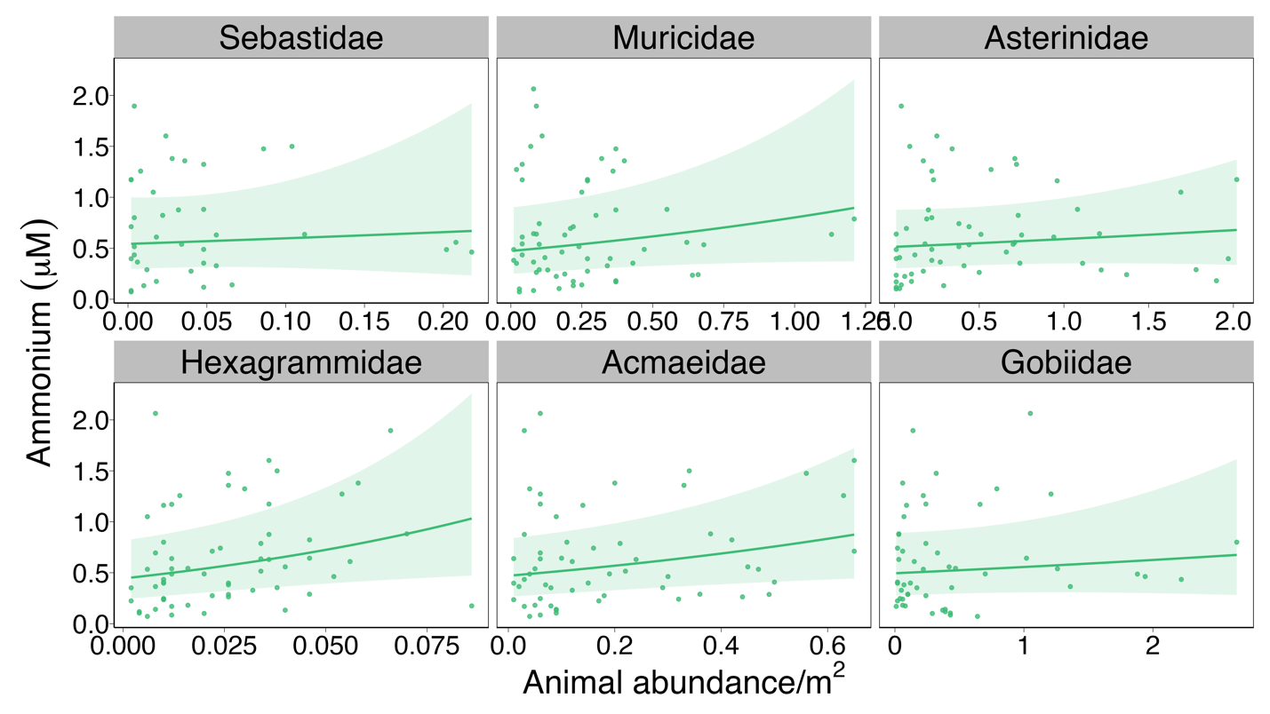
Supplemental Figure 1. Model-generated predictions of ammonium concentrations in relation to abundance across rocky reef sites for the 6 animal families with the highest R².

Supplemental Table 1. Model summaries from the among-site, meso-scale models including only the biomass of one family for each model.

Sebastidae
Estimate Std. Error z value Pr(>|z|)
(Intercept) 0.13333 1.23129 0.108 0.914
fam_den_scale 1.97572 3.21833 0.614 0.539
tide_scale -0.52577 1.00087 -0.525 0.599
shannon_scale -0.09965 0.13231 -0.753 0.451
depth_avg_scale -0.02276 0.12990 -0.175 0.861
fam_den_scale:tide_scale -1.78560 2.81804 -0.634 0.526

Muricidae
Estimate Std. Error z value Pr(>|z|)
(Intercept) -0.434858 0.333427 -1.304 0.192
fam_den_scale 0.793932 0.513936 1.545 0.122
tide_scale 0.053399 0.121424 0.440 0.660
shannon_scale -0.003838 0.097453 -0.039 0.969
depth_avg_scale 0.039007 0.091700 0.425 0.671
fam_den_scale:tide_scale 0.122610 0.553062 0.222 0.825

Asterinidae
Estimate Std. Error z value Pr(>|z|)
(Intercept) -0.58081 0.25501 -2.278 0.0228 *
fam_den_scale 0.20689 0.25841 0.801 0.4233
tide_scale 0.12450 0.06909 1.802 0.0715 .
shannon_scale -0.11586 0.09008 -1.286 0.1984
depth_avg_scale 0.05520 0.08902 0.620 0.5352
fam_den_scale:tide_scale 0.06921 0.27150 0.255 0.7988

Hexagrammidae
Estimate Std. Error z value Pr(>|z|)
(Intercept) 4.960945 2.539162 1.954 0.0507 .
fam_den_scale 14.671724 6.691550 2.193 0.0283 *
tide_scale -3.349292 2.012201 -1.665 0.0960 .
shannon_scale 0.009674 0.088138 0.110 0.9126
depth_avg_scale 0.021288 0.086719 0.246 0.8061
fam_den_scale:tide_scale -9.007885 5.353635 -1.683 0.0925 .

Acmaeidae
Estimate Std. Error z value Pr(>|z|)
(Intercept) -0.194057 0.329224 -0.589 0.5556
fam_den_scale 1.424749 0.669551 2.128 0.0333 *
tide_scale 0.032068 0.155457 0.206 0.8366
shannon_scale -0.007977 0.093207 -0.086 0.9318
depth_avg_scale 0.004841 0.092253 0.052 0.9582
fam_den_scale:tide_scale -0.162030 0.577448 -0.281 0.7790

Gobiidae
Estimate Std. Error z value Pr(>|z|)
(Intercept) -0.64053 0.29309 -2.185 0.0289 *
fam_den_scale 0.17168 0.22942 0.748 0.4543
tide_scale 0.03806 0.07359 0.517 0.6050
shannon_scale -0.01094 0.09648 -0.113 0.9098
depth_avg_scale -0.06208 0.11275 -0.551 0.5819
fam_den_scale:tide_scale 0.13329 0.16709 0.798 0.4250

Within-site (small-scale) variation
As above, we further explored the effect of animals on ∆NH₄⁺ – the difference in NH₄⁺ concentration between inside and outside kelp forests – by rerunning our the top LMM in Table S5 with the biomass of only one animal family at a time. We ran models for the 15 most abundant species, but only present the three fish families (Gobiidae, Cottidae, and Embiotocidae) and three invertebrate families (Echinasteridae, Strongylocentrotidae, and Asteriidae) with the highest R² values. These six families contribute almost half (48%) of the total biomass observed on the surveys.
We found a negative relationship between ∆NH₄⁺ and the biomass of gobies (Gobiidae) and evidence of positive kelp:goby biomass and tide:goby biomass interactions (GLM, p < 0.003, Supplemental Figure 2). ∆NH₄⁺ was positively correlated with the biomass of sculpins (Cottidae; p = 0.046) and surfperches (Embiotocidae; p < 0.001), but no interactions with biomass were significant (p > 0.06). Sea stars in the family Echinasteridae displayed a positive relationship with ∆NH₄⁺, a negative kelp:sea star biomass interaction, and a positive tide:sea star biomass interaction (p < 0.001). We found evidence for a smaller but still positive relationship between the biomass of urchins in the family Strongylocentrotidae and sea stars in the family Asteropseidae and ∆NH₄⁺ (p < 0.005), but no interactions with biomass were significant (p > 0.17). Full model outputs are available in Supplemental Table 2.

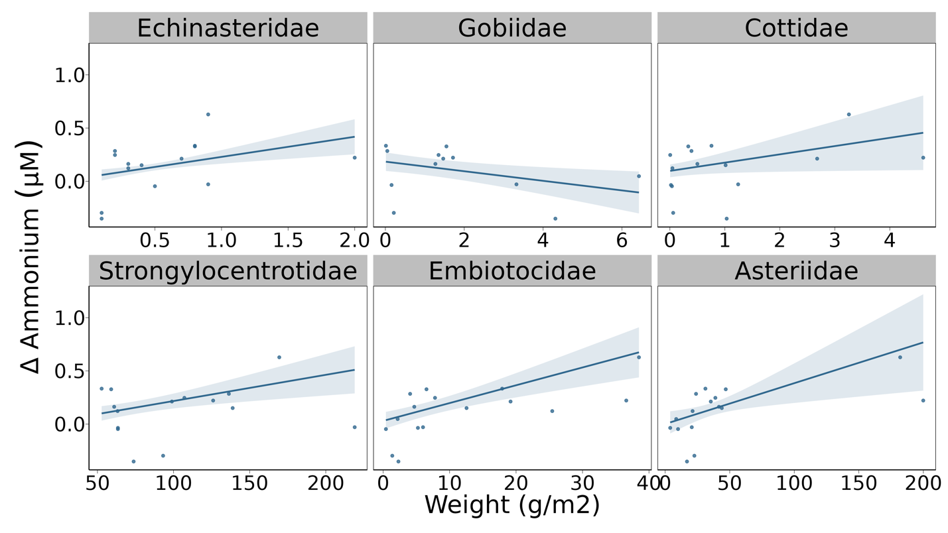
Supplemental Figure 2. Model-generated predictions of difference in ammonium concentrations between inside and outside kelp forests in relation to animal biomass for the 6 animal families with the highest R²

Supplemental Table 2. Model summaries from the within-site, small scale models including only the biomass of one family for each model.

Echinasteridae
Estimate Std. Error z value Pr(>|z|)
(Intercept) 3.22472 0.70794 4.555 5.24e-06 ***
kelp_spnereo 0.23457 0.03453 6.793 1.10e-11 ***
kelp_spnone -0.08853 0.06650 -1.331 0.183088
kelp_bio_scale -2.81761 0.88787 -3.173 0.001506 **
tide_scale 3.01942 0.75719 3.988 6.67e-05 ***
weight_den_fam_scale 7.35886 1.67832 4.385 1.16e-05 ***
shannon_scale -0.12606 0.02115 -5.959 2.53e-09 ***
depth_scale 0.04027 0.01837 2.192 0.028381 *
kelp_bio_scale:tide_scale 0.20281 0.03761 5.392 6.97e-08 ***
kelp_bio_scale:weight_den_fam_scale -7.65598 2.14144 -3.575 0.000350 ***
tide_scale:weight_den_fam_scale 6.87200 1.78273 3.855 0.000116 ***

Gobiidae
Estimate Std. Error z value Pr(>|z|)
(Intercept) -0.55547 0.23654 -2.348 0.018857 *
kelp_spnone 0.88797 0.34010 2.611 0.009031 **
kelp_bio_scale 1.06405 0.37849 2.811 0.004934 **
tide_scale 4.79062 0.98052 4.886 1.03e-06 ***
weight_den_fam_scale -1.71304 0.56978 -3.006 0.002643 **
shannon_scale 0.13727 0.03868 3.549 0.000387 ***
depth_scale -0.00280 0.02937 -0.095 0.924042
kelp_bio_scale:tide_scale 0.11384 0.08461 1.345 0.178486
kelp_bio_scale:weight_den_fam_scale 2.64764 0.98325 2.693 0.007087 **
tide_scale:weight_den_fam_scale 12.21684 2.47943 4.927 8.34e-07 ***

Cottidae
Estimate Std. Error z value Pr(>|z|)
(Intercept) 1.23122 0.56070 2.196 0.028102 *
kelp_spnereo 0.11919 0.07321 1.628 0.103523
kelp_spnone -0.43416 0.09321 -4.658 3.19e-06 ***
kelp_bio_scale -0.35380 0.36761 -0.962 0.335844
tide_scale -0.67897 1.14142 -0.595 0.551943
weight_den_fam_scale 2.55957 1.28229 1.996 0.045924 *
shannon_scale -0.15608 0.03545 -4.402 1.07e-05 ***
depth_scale 0.10973 0.02875 3.817 0.000135 ***
kelp_bio_scale:tide_scale 0.17294 0.08104 2.134 0.032851 *
kelp_bio_scale:weight_den_fam_scale -1.58585 0.85911 -1.846 0.064904 .
tide_scale:weight_den_fam_scale -1.88287 2.68459 -0.701 0.483077

Strongylocentrotidae
Estimate Std. Error z value Pr(>|z|)
(Intercept) 0.0004341 0.0570275 0.008 0.99393
kelp_spnereo 0.0661813 0.0798662 0.829 0.40730
kelp_spnone -0.6711153 0.1241935 -5.404 6.52e-08 ***
kelp_bio_scale 0.1965326 0.0574934 3.418 0.00063 ***
tide_scale 0.0663294 0.0669569 0.991 0.32187
weight_den_fam_scale 0.0808835 0.0251885 3.211 0.00132 **
shannon_scale 0.0400143 0.0349902 1.144 0.25280
depth_scale 0.0994891 0.0310032 3.209 0.00133 **
kelp_bio_scale:tide_scale 0.1472693 0.0605091 2.434 0.01494 *
kelp_bio_scale:weight_den_fam_scale -0.0168616 0.0150645 -1.119 0.26301
tide_scale:weight_den_fam_scale -0.0239569 0.0225873 -1.061 0.28886

Embiotocidae
Estimate Std. Error z value Pr(>|z|)
(Intercept) 0.27008 0.04271 6.324 2.55e-10 ***
kelp_spnereo -0.03453 0.07745 -0.446 0.655717
kelp_spnone -0.28231 0.13383 -2.109 0.034908 *
kelp_bio_scale 0.24745 0.04663 5.307 1.11e-07 ***
tide_scale 0.15179 0.04062 3.736 0.000187 ***
weight_den_fam_scale 0.55061 0.11968 4.601 4.21e-06 ***
shannon_scale -0.08701 0.03058 -2.846 0.004434 **
depth_scale 0.07119 0.02975 2.393 0.016713 *
kelp_bio_scale:tide_scale 0.18242 0.06991 2.609 0.009068 **
kelp_bio_scale:weight_den_fam_scale -0.05275 0.10959 -0.481 0.630243
tide_scale:weight_den_fam_scale 0.31241 0.19648 1.590 0.111832

Asteriidae
Estimate Std. Error z value Pr(>|z|)
(Intercept) 0.056277 0.041953 1.341 0.17978
kelp_spnereo 0.047528 0.092364 0.515 0.60685
kelp_spnone -0.242165 0.111039 -2.181 0.02919 *
kelp_bio_scale 0.234677 0.074798 3.138 0.00170 **
tide_scale -0.018518 0.081987 -0.226 0.82131
weight_den_fam_scale 0.126168 0.045779 2.756 0.00585 **
shannon_scale -0.098288 0.031823 -3.089 0.00201 **
depth_scale 0.047207 0.030279 1.559 0.11898
kelp_bio_scale:tide_scale 0.115009 0.075756 1.518 0.12898
kelp_bio_scale:weight_den_fam_scale 0.004679 0.028540 0.164 0.86978
tide_scale:weight_den_fam_scale 0.125188 0.095002 1.318 0.18759

References
Allgeier, J.E., Burkepile, D.E., Layman, C.A., 2017. Animal pee in the sea: consumer-mediated nutrient dynamics in the world’s changing oceans. Glob Change Biol 23, 2166–2178. https://doi.org/10.1111/gcb.13625
Allgeier, J.E., Yeager, L.A., Layman, C.A., 2013. Consumers regulate nutrient limitation regimes and primary production in seagrass ecosystems. Ecology 94, 521–529. https://doi.org/10.1890/12-1122.1
Aquilino, K.M., Bracken, M.E.S., Faubel, M.N., Stachowicz, J.J., 2009. Local-scale nutrient regeneration facilitates seaweed growth on wave-exposed rocky shores in an upwelling system. Limnol Oceanogr 54, 309–317. https://doi.org/10.4319/lo.2009.54.1.0309
Archer, S.K., Allgeier, J.E., Semmens, B.X., Heppell, S.A., Pattengill-Semmens, C.V., Rosemond, A.D., Bush, P.G., McCoy, C.M., Johnson, B.C., Layman, C.A., 2015. Hot moments in spawning aggregations: implications for ecosystem-scale nutrient cycling. Coral Reefs 34, 19–23. https://doi.org/10.1007/s00338-014-1208-4
Attridge, C.M., Cox, K.D., Maher, B., Gross, S., Lim, E.G., Kattler, K.R., Côté, I.M., 2024. Studying Kelp Forests of Today to Forecast Ecosystems of the Future. Fisheries 49, 181–187. https://doi.org/10.1002/fsh.11065
Benkwitt, C.E., Wilson, S.K., Graham, N.A.J., 2019. Seabird nutrient subsidies alter patterns of algal abundance and fish biomass on coral reefs following a bleaching event. Glob Change Biol 25, 2619–2632. https://doi.org/10.1111/gcb.14643
Brooks, M.E., Kristensen, K., van Benthem, K.J., Magnusson, A., Berg, C.W., Nielsen, A., Skaug, H.J., Mächler, M., Bolker, B.M., 2017. glmmTMB balances speed and flexibility among packages for zero-inflated generalized linear mixed modeling. The R Journal 9, 378. https://doi.org/10.32614/RJ-2017-066
Brzezinksi, M., Reed, D., Harrer, S., Rassweiler, A., Melack, J., Goodridge, B., Dugan, J., 2013. Multiple sources and forms of nitrogen sustain year-round kelp growth on the inner continental shelf of the Santa Barbara Channel. Oceanog 26, 114–123. https://doi.org/10.5670/oceanog.2013.53
Dayton, P.K., Tegner, M.J., Edwards, P.B., Riser, K.L., 1999. Temporal and Spatial Scales of Kelp Demography: The Role of Oceanographic Climate. Ecological Monographs 69, 219–250. https://doi.org/10.1890/0012-9615(1999)069[0219:TASSOK]2.0.CO;2
Doughty, C.E., Roman, J., Faurby, S., Wolf, A., Haque, A., Bakker, E.S., Malhi, Y., Dunning, J.B., Svenning, J.-C., 2016. Global nutrient transport in a world of giants. Proceedings of the National Academy of Sciences 113, 868–873. https://doi.org/10.1073/pnas.1502549112
Edgar, G., Stuart-Smith, R., 2009. Ecological effects of marine protected areas on rocky reef communities—a continental-scale analysis. Mar. Ecol. Prog. Ser. 388, 51–62. https://doi.org/10.3354/meps08149
Edgar, G.J., Cooper, A., Baker, S.C., Barker, W., Barrett, N.S., Becerro, M.A., Bates, A.E., Brock, D., Ceccarelli, D.M., Clausius, E., Davey, M., Davis, T.R., Day, P.B., Green, A., Griffiths, S.R., Hicks, J., Hinojosa, I.A., Jones, B.K., Kininmonth, S., Larkin, M.F., Lazzari, N., Lefcheck, J.S., Ling, S.D., Mooney, P., Oh, E., Pérez-Matus, A., Pocklington, J.B., Riera, R., Sanabria-Fernandez, J.A., Seroussi, Y., Shaw, I., Shields, D., Shields, J., Smith, M., Soler, G.A., Stuart-Smith, J., Turnbull, J., Stuart-Smith, R.D., 2020. Establishing the ecological basis for conservation of shallow marine life using Reef Life Survey. Biological Conservation 252, 108855. https://doi.org/10.1016/j.biocon.2020.108855
Francis, F.T., Côté, I.M., 2018. Fish movement drives spatial and temporal patterns of nutrient provisioning on coral reef patches. Ecosphere 9, e02225. https://doi.org/10.1002/ecs2.2225
Froese, R., Thorson, J.T., Reyes Jr, R.B., 2014. A Bayesian approach for estimating length-weight relationships in fishes. Journal of Applied Ichthyology 30, 78–85. https://doi.org/10.1111/jai.12299
Gaylord, B., Rosman, J.H., Reed, D.C., Koseff, J.R., Fram, J., MacIntyre, S., Arkema, K., McDonald, C., Brzezinski, M.A., Largier, J.L., Monismith, S.G., Raimondi, P.T., Mardian, B., 2007. Spatial patterns of flow and their modification within and around a giant kelp forest. Limnology and Oceanography 52, 1838–1852. https://doi.org/10.4319/lo.2007.52.5.1838
Gruner, D.S., Smith, J.E., Seabloom, E.W., Sandin, S.A., Ngai, J.T., Hillebrand, H., Harpole, W.S., Elser, J.J., Cleland, E.E., Bracken, M.E.S., Borer, E.T., Bolker, B.M., 2008. A cross-system synthesis of consumer and nutrient resource control on producer biomass. Ecol Lett 11, 740–755. https://doi.org/10.1111/j.1461-0248.2008.01192.x
Hartig, F., 2022. DHARMa: Residual Diagnostics for Hierarchical (Multi-Level / Mixed) Regression Models. R package version 0.4.6.
Holbrook, S.J., Brooks, A.J., Schmitt, R.J., Stewart, H.L., 2008. Effects of sheltering fish on growth of their host corals. Mar Biol 155, 521–530. https://doi.org/10.1007/s00227-008-1051-7
Holmes, R.M., Aminot, A., Kerouel, R., Hooker, B.A., Peterson, B.J., 1999. A simple and precise method for measuring ammonium in marine and freshwater ecosystems. Canadian Journal of Fisheries and Aquatic Sciences 56, 1801–1808. https://doi.org/10.1139/f99-128
Howard, B.R., Francis, F.T., Côté, I.M., Therriault, T.W., 2019. Habitat alteration by invasive European green crab (Carcinus maenas) causes eelgrass loss in British Columbia, Canada. Biol Invasions 21, 3607–3618. https://doi.org/10.1007/s10530-019-02072-z
Layman, C.A., Allgeier, J.E., Montaña, C.G., 2016. Mechanistic evidence of enhanced production on artificial reefs: A case study in a Bahamian seagrass ecosystem. Ecol Eng 95, 574–579. https://doi.org/10.1016/j.ecoleng.2016.06.109
Leibold, M.A., 1991. Biodiversity and nutrient enrichment in pond plankton communities. Evol. Ecol. Res 1, 73–95.
Lobban, C.S., Harrison, P.J., 1994. Seaweed Ecology and Physiology. Cambridge University Press.
Lowman, H.E., Hirsch, M.E., Brzezinski, M.A., Melack, J.M., 2023. Examining the Potential of Sandy Marine Sediments Surrounding Giant Kelp Forests to Provide Recycled Nutrients for Growth. Journal of Coastal Research 39, 442–454. https://doi.org/10.2112/JCOASTRES-D-22-00035.1
Mann, K.H., 1973. Seaweeds: Their Productivity and Strategy for Growth. Science 182, 975–981. https://doi.org/10.1126/science.182.4116.975
McInturf, A.G., Pollack, L., Yang, L.H., Spiegel, O., 2019. Vectors with autonomy: what distinguishes animal-mediated nutrient transport from abiotic vectors? Biological Reviews 94, 1761–1773. https://doi.org/10.1111/brv.12525
Menge, B.A., 1992. Community Regulation: Under What Conditions Are Bottom-Up Factors Important on Rocky Shores? Ecology 73, 755–765. https://doi.org/10.2307/1940155
Meyer, J.L., Schultz, E.T., 1985. Migrating haemulid fishes as a source of nutrients and organic matter on coral reefs. Limnol Oceanogr 30, 146–156.
Meyer, J.L., Schultz, E.T., Helfman, G.S., 1983. Fish schools: An asset to corals. Science 220, 1047–1049. https://doi.org/10.1126/science.220.4601.1047
Nielsen, K.J., Navarrete, S.A., 2004. Mesoscale regulation comes from the bottom-up: intertidal interactions between consumers and upwelling. Ecology Letters 7, 31–41. https://doi.org/10.1046/j.1461-0248.2003.00542.x
Oksanen, J., Simpson, G.L., Blanchet, F.G., Kindt, R., Legendre, P., Minchin, P.R., O’Hara, R.B., Solymos, P., Stevens, M.H.H., Szoecs, E., Wagner, H., Barbour, M., Bedward, M., Bolker, B., Borcard, D., Carvalho, G., Chirico, M., Caceres, M.D., Durand, S., Evangelista, H.B.A., FitzJohn, R., Friendly, M., Furneaux, B., Hannigan, G., Hill, M.O., Lahti, L., McGlinn, D., Ouellette, M.-H., Cunha, E.R., Smith, T., Stier, A., Braak, C.J.F.T., Weedon, J., 2022. vegan: Community Ecology Package. R package version 2.6-4.
Paine, R.T., 1986. Benthic community—water column coupling during the 1982-1983 El Niño. Are community changes at high latitudes attributable to cause or coincidence?1. Limnology and Oceanography 31, 351–360. https://doi.org/10.4319/lo.1986.31.2.0351
Pawlowicz, R., 2017. Seasonal cycles, hypoxia, and renewal in a coastal fjord (Barkley Sound, British Columbia). Atmosphere-Ocean 55, 264–283. https://doi.org/10.1080/07055900.2017.1374240
Peters, J.R., Reed, D.C., Burkepile, D.E., 2019. Climate and fishing drive regime shifts in consumer-mediated nutrient cycling in kelp forests. Glob Change Biol 25, 3179–3192. https://doi.org/10.1111/gcb.14706
Pfister, C.A., Altabet, M.A., Post, D., 2014. Animal regeneration and microbial retention of nitrogen along coastal rocky shores. Ecology 95, 2803–2814. https://doi.org/10.1890/13-1825.1
Pfister, C.A., Altabet, M.A., Weigel, B.L., 2019. Kelp beds and their local effects on seawater chemistry, productivity, and microbial communities. Ecology 100, e02798. https://doi.org/10.1002/ecy.2798
Phillips, J.C., Hurd, C.L., 2004. Kinetics of nitrate, ammonium, and urea uptake by four intertidal seaweeds from New Zealand. J Phycol 40, 534–545. https://doi.org/10.1111/j.1529-8817.2004.03157.x
Probyn, T.A., Chapman, A.R.O., 1983. Summer growth of Chordaria flagelliformis (O.F. Muell.) C. Ag.: Physiological strategies in a nutrient stressed environment. Journal of Experimental Marine Biology and Ecology 73, 243–271. https://doi.org/10.1016/0022-0981(83)90050-3
R Core Team, 2019. R: A language and environment for statistical computing.
Roman, J., McCarthy, J.J., 2010. The Whale Pump: Marine Mammals Enhance Primary Productivity in a Coastal Basin. PLoS ONE 5, e13255. https://doi.org/10.1371/journal.pone.0013255
RStudio Team, 2016. RStudio: Integrated development for R.
Sellers, A.J., Leung, B., Torchin, M.E., 2020. Global meta-analysis of how marine upwelling affects herbivory. Global Ecology and Biogeography 29, 370–383. https://doi.org/10.1111/geb.13023
Shantz, A.A., Ladd, M.C., Schrack, E., Burkepile, D.E., 2015. Fish-derived nutrient hotspots shape coral reef benthic communities. Ecological Applications 25, 2142–2152. https://doi.org/10.1890/14-2209.1
Shrestha, J., Coale, K.H., Hamilton, S.L., 2023. Empirical measurements of ammonium excretion in kelp forest fishes: Effects of body size, taxonomy and trophic guild. Journal of Experimental Marine Biology and Ecology 569, 151956. https://doi.org/10.1016/j.jembe.2023.151956
Starko, S., Neufeld, C.J., Gendall, L., Timmer, B., Campbell, L., Yakimishyn, J., Druehl, L., Baum, J.K., 2022. Microclimate predicts kelp forest extinction in the face of direct and indirect marine heatwave effects. Ecological Applications 32, e2673. https://doi.org/10.1002/eap.2673
Starko, S., Timmer, B., Reshitnyk, L., Csordas, M., McHenry, J., Schroeder, S., Hessing-Lewis, M., Costa, M., Zielinksi, A., Zielinksi, R., Cook, S., Underhill, R., Boyer, L., Fretwell, C., Yakimishyn, J., Heath, W., Gruman, C., Hingmire, D., Baum, J., Neufeld, C., 2024. Local and regional variation in kelp loss and stability across coastal British Columbia. Mar. Ecol. Prog. Ser. 733, 1–26. https://doi.org/10.3354/meps14548
Steneck, R.S., Graham, M.H., Bourque, B.J., Corbett, D., Erlandson, J.M., Estes, J.A., Tegner, M.J., 2002. Kelp forest ecosystems: biodiversity, stability, resilience and future. Environmental Conservation 29, 436–459. https://doi.org/10.1017/S0376892902000322
Tanasichuk, R., 1998. Interannual variations in the population biology and productivity of Euphausia pacifica in Barkley Sound, Canada, with special reference to the 1992 and 1993 warm ocean years. Mar. Ecol. Prog. Ser. 173, 163–180. https://doi.org/10.3354/meps173163
Taylor, B.W., Keep, C.F., Hall, R.O., Koch, B.J., Tronstad, L.M., Flecker, A.S., Ulseth, A.J., 2007. Improving the fluorometric ammonium method: matrix effects, background fluorescence, and standard additions. Journal of the North American Benthological Society 26, 167–177. https://doi.org/10.1899/0887-3593(2007)26[167:ITFAMM]2.0.CO;2
Tilman, G.D., 1984. Plant Dominance Along an Experimental Nutrient Gradient. Ecology 65, 1445–1453. https://doi.org/10.2307/1939125
Uthicke, S., 2001. Nutrient regeneration by abundant coral reef holothurians. J. Exp. Mar. Biol. Ecol. 265, 153–170. https://doi.org/10.1016/S0022-0981(01)00329-X
Vanni, M.J., 2002. Nutrient cycling by animals in freshwater ecosystems. Annu Rev Ecol Syst 33, 341–370. https://doi.org/10.1146/annurev.ecolsys.33.010802.150519
Wickham, H., Averick, M., Bryan, J., Chang, W., McGowan, L.D., François, R., Grolemund, G., Hayes, A., Henry, L., Hester, J., Kuhn, M., Pedersen, T.L., Miller, E., Bache, S.M., Müller, K., Ooms, J., Robinson, D., Seidel, D.P., Spinu, V., Takahashi, K., Vaughan, D., Wilke, C., Woo, K., Yutani, H., 2019. Welcome to the Tidyverse. Journal of Open Source Software 4, 1686. https://doi.org/10.21105/joss.01686

Discussion notes

- Talk about Cedeno et al., 2021 paper!!! They suggest nitrates = temporal variation in nutrients, but ammonium/regeneration = spatial variation in where animals are! Show surge uptake in Macro, so they just need to be exposed to a burst of strong fish pee = take up and store tons of nitrogen.

- Pfister, Altabet and Weigel 2019 also did pee inside vs out, but only 3 forests and inside vs offshore

- Stewart et al 2009 also did inside vs out

- Make sure to compare magnitudes of variation! 0 – 20 umol nitrite, what increases did Pfister or Aquilio find?

